**Feedback Control Systems**

**Lab Report 2**

**Hafiz Ahmad**

**19l-1316**

**Section-6B2**

Frequency Sweep of Second Order System

**INTRODUCTION:**

The term "second order system" refers to a system whose input-output equation is a second-order differential equation. Oscillations and overshoots are common features of these straightforward systems. In mechanical systems, energy is stored in the form of inertia, whereas in electrical systems, energy is stored in capacitors and inductors. Higher order systems are based on second order systems. Therefore, a RLC circuit serves as the system's electrical circuit. In the previous tutorial, we learned about first order systems and how they respond to various inputs with the help of Scilab and XCOS. In this tutorial we will continue our time response analysis journey with second order systems.As you might have already guessed, second order systems are those systems where the highest power of ‘s’ in the denominator of the transfer function is two. In other words, these are systems with two poles.

**OBJECTIVES:**

• To learn more about by observing and plot frequency sweep of second order systems.

**Equipment Required:**

• Oscilloscope with probes

• Function generator with probes

• Digital multi-meter

• Dual Power supply

• Breadboard

• Capacitor 1nF, Inductor 150mH, Resistor 1KΩ

**Procedure:**

We were given four circuits for this lab, so we built each one on a breadboard first. Then, using the function generator, we changed the frequency from 100 Hz to 40 kHz and recorded the voltage at the circuit's output side and entered it into the table. After that, we converted our DB readings and plotted each system's frequency response. Diagram, engineering drawing, schematic

**Observations & Calculations:**

**Table:**

|  |  |
| --- | --- |
| Resistor | 1K OHMS |
| Capacitor | 1nF |
| Inductor | 150mH |

|  |  |  |  |  |  |
| --- | --- | --- | --- | --- | --- |
| **Frequency**  **(Hz)** | **Vin** | **Sys** | **tem 1** | **System 2** | |
| **Vout** | **Vout(dB)** | **Vout (V)** | **Vout(dB)** |
| 100 | 4 | 1.44 | 3.167 | 21.3m | -33.43 |
| 500 | 4 | 1.4439 | 3.161 | 20.2m | -33.89 |
| 1000 | 4 | 1.437 | 3.149 | 22.3m | -33 |
| 5000 | 4 | 1.436 | 3.143 | 43.8m | -27 |
| 10,000 | 4 | 1.416 | 3.021 | 88.9m | -21.02 |
| 15,000 | 4 | 1.387 | 2.841 | 133.5m | -17.5 |
| 20,000 | 4 | 1.35 | 2.606 | 177.3m | -15.03 |
| 25,000 | 4 | 1.309 | 2.339 | 220.2m | -13.14 |
| 30,000 | 4 | 1.267 | 2.055 | 262.9m | -11.6 |
| 35,000 | 4 | 1.219 | 1.720 | 303.9m | -10.345 |
| 40,000 | 4 | 1.17 | 1.364 | 343.7m | -9.28 |
| 50,000 | 4 | 1.07 | 0.587 | 419.6m | -7.54 |
| 100,000 | 4 | 0.69 | -3.223 | 0.711 | -2.97 |

|  |  |  |  |  |  |
| --- | --- | --- | --- | --- | --- |
| **Frequency**  **(Hz)** | **Vin (vpp)** | **Sys** | **tem 3** | **System 4** | |
| **Vout (mV)** | **Vout(dB)** | **Vout** | **Vout(dB)** |
| 100 | 4 | 21 | -33.5 | 1.143 | 1.16 |
| 500 | 4 | 21.6 | -33.31 | 1.313 | 2.365 |
| 1000 | 4 | 22.3 | -33.03 | 1.353 | 2.626 |
| 5000 | 4 | 52.6 | -25.58 | 1.37 | 2.77734 |
| 10,000 | 4 | 220 | -13.15 | 1.371 | 2.71 |
| 15,000 | 4 | 341.6 | -.933 | 1.3699 | 2.734 |
| 20,000 | 4 | 127.3 | -17.9 | 1.3692 | 2.73 |
| 25,000 | 4 | 79 | -22.04 | 1.3687 | 2.726 |
| 30,000 | 4 | 57 | -24.88 | 1.372 | 2.747 |
| 35,000 | 4 | 44.02 | -27.13 | 1.3718 | 2.746 |
| 40,000 | 4 | 35.3 | -29 | 1.3715 | 2.744 |
| 50.000 | 4 | 23.2 | -32.69 | 1.3707 | 2.739 |
| 100,000 | 4 | 20.2 | -33.89 | 1.3642 | 2.693 |
| 500,000 | 4 | 25.2 | -37.97 | 1.033 | 0.282 |
| 1,000,000 | 4 | 21.2 | -33.47 | 0.26 | -11.701 |

**GRAPHS:**

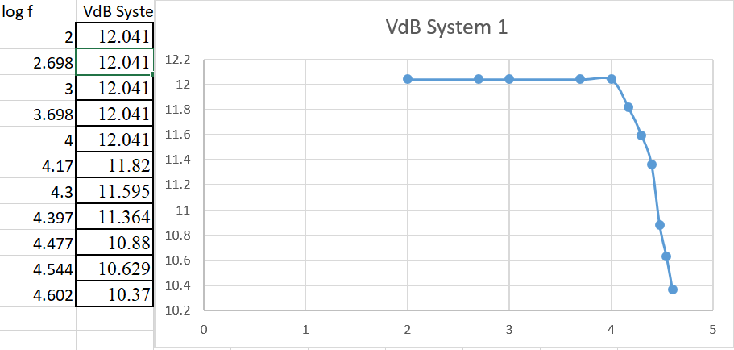

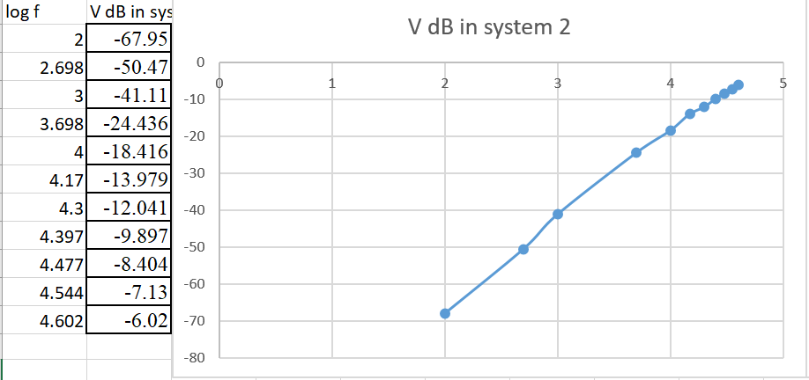

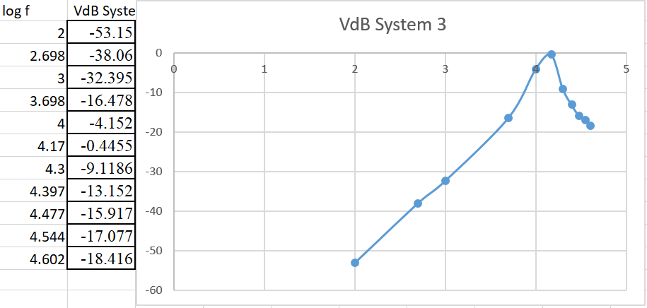

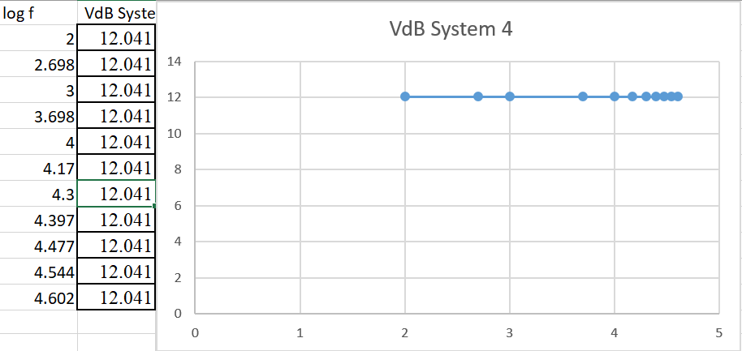

**Application:**

This lab helped us understand a variety of second-order systems, which will be useful in subsequent labs.It is the time required for the response to reach half of its final value from the zero instant. It is denoted by tdtd. Consider the step response of the second order system for t ≥ 0, when 'δ' lies between zero and one. It is the time required for the response to rise from 0% to 100% of its final value. The second-order system is the lowest-order system capable of an oscillatory response to a step input. Typical examples are the spring-mass-damper system and the electronic RLC circuit.

* Cooling /Warming Law
* Population growth and decay
* Radioactive decay and carbon dating
* Series circuit
* Draining a tank

**Issues:**

No major issue found while performing the lab.

**Conclusion:**

We can learn how changes in frequency affect various second-order systems from this lab. The term "second order system" refers to a system whose input-output equation is a second-order differential equation. Second order systems are significant for a number of reasons. They have oscillations and overshoot, are straightforward, and Second-order systems are the foundation of higher order systems.

**Post lab:**

**Explain the observations made during the performance of the lab experiment.**

All four systems acted in different ways when they did the lab task. As the frequency rises, the first system decreases. The frequency of the second system is increasing. The fourth filter is decreasing, but at a very low rate that appears to be almost constant, while the third system is serving as a band pass filter, allowing a particular frequency band to pass through it.

**Would the frequency sweep of each second order system be altered if the value of inductor or capacitor was changed? If so, why?**

Yes, with frequency, the effective inductance of almost any practical component will change. The device's behavior will typically be dominated by the inter-winding capacitance above a certain frequency, resulting in a negative and decreasing reactance rather than a positive and increasing reactance.